*Case Study(Report)*

‘Accounts Payable Database’

***Student Details:***

* ***Rishabh Rajpurohit (9919103096)***
* ***Soumya Gupta (9919103120)***
* ***P. Paul Jonathan (9919103121)***



## Database Systems and Web Lab

## Jaypee Institute of Information Technology Noida

#### July 11, 2021

# ACKNOWLEDGEMENT

Presentation inspiration and motivation have always played a key role in the success of any venture.

We pay our deep sense of gratitude to, **Vice Chancellor Dr. S C Saxena**, **Jaypee institute of information technology, Noida** to encourage us to the highest peak and to provide us the opportunity to prepare the project. We are immensely obliged to for their elevating inspiration, encouraging guidance and kind supervision in the completion of our project.

We feel to acknowledge our indebtedness and deep sense of gratitude to our guide ***Mrs. Vartika Puri*** whose invaluable guidance and kind supervision given to us throughout the course which shaped the present work as its show.

Last, but not the least, **our parents** are also an important inspiration for time. So with due regards. We express our gratitude.

***TABLE OF CONTENT***

ACKNOWLEDGEMENT 2

1. **PART:1** 5

*1.1 TITLE / EER* 5

*1.2 APPLICATIONS* 6

2. **PART:2** 7

*2.1 CREATING RELATIONS* 7

2.2 *INSERTING VALUES* 8

3. **PART:3** 12

*3.1 QUERY: TRIGGER 1* 12

*3.2 QUERY: TRIGGER 2* 13

*3.3 QUERY: TRIGGER 2* 14

*3.4 QUERY: PROCEDURE 1* 15

*3.5 QUERY: PROCEDURE 2* 17

*3.6 QUERY: PROCEDURE 3* 21

*3.7 QUERY: SCHEDULED EVENT 1* 24

4. **BIBLIOGRAPHY** 25

## PART:1

### *1.1 TITLE / EER*

*‘Accounts Payable’* Database

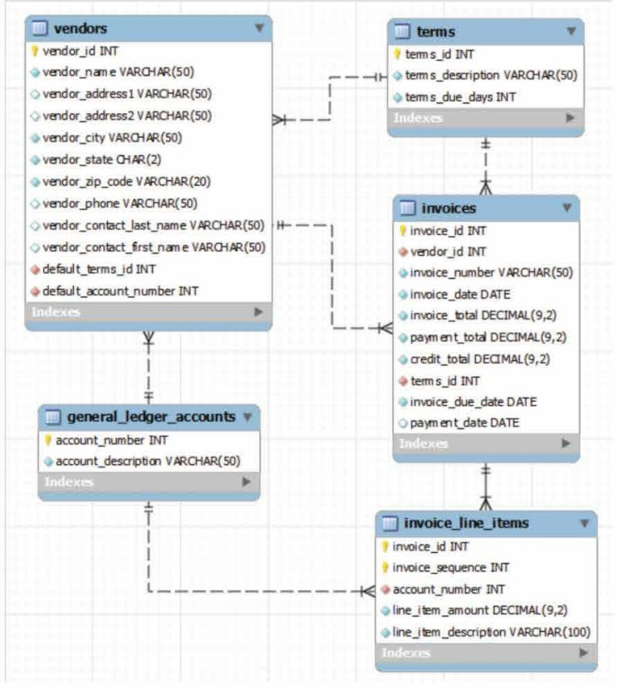  
***EER*** *Diagram for the database*

### *1.2 APPLICATIONS*

By Implementing the above project in real time database:

* we can automate the manual stuff like keeping records of due payments
* sending alerts for upcoming payments
* charging penalties
* updating late fees daily automatically and
* offering discounts wherever needed

Thus this reduces the scope of error and greatly reduces human efforts.

## PART:2

### *CREATING RELATIONS*

use dswproject;

create table invoices(

  invoice_id int primary key AUTO_INCREMENT,

  vendor_id int not null,

  invoice_number VARCHAR(50) not null,

  invoice_date date not null,

  invoice_total decimal(9, 2) default 0,

  credit_total decimal(9, 2) DEFAULT 0,

  terms_id int not null,

  invoice_due_date date,

  payment_date date

);

CREATE table terms(

  terms_id INT PRIMARY key AUTO_INCREMENT,

  terms_description VARCHAR(50) NOT NULL,

  terms_due_days int

);

CREATE TABLE vendors(

  vendor_id int PRIMARY key AUTO_INCREMENT,

  vendor_name VARCHAR (50) not null,

  vendor_address1 VARCHAR (50) not null,

  vendor_address2 VARCHAR (50),

  vendor_city VARCHAR (50),

  vendor_state char(20),

  vendor_zip_code VARCHAR (20),

  vendor_phone VARCHAR (50),

  vendor_contact_last_name VARCHAR (50),

  vendor_contact_first_name VARCHAR (50),

  default_terms_id int not null,

  default_account_number int not null

);

CREATE table general_ledger_accounts(

  account_number int PRIMARY KEY AUTO_INCREMENT,

  account_description VARCHAR (50)

);

CREATE TABLE invoice_line_items(

    invoice_id int not null,

    invoice_sequence int not null,

    account_number int not null,

    line_item_amount decimal(9,2) not null,

    line_item_description VARCHAR (100),

    PRIMARY key(invoice_id, invoice_sequence),

    FOREIGN key(account_number) REFERENCES general_ledger_accounts (account_number)

);

alter table invoices

add constraint invoices_fk_vendors FOREIGN key (vendor_id) REFERENCES vendors (vendor_id),

add constraint invoices_fk_terms FOREIGN key (terms_id) REFERENCES terms (terms_id);

ALTER TABLE vendors

add constraint vendors_fk_terms FOREIGN key (default_terms_id) REFERENCES terms (terms_id),

add constraint vendors_fk_accounts FOREIGN key (default_account_number) REFERENCES general_ledger_accounts (account_number);

### *INSERTING VALUES*

INSERT INTO

`general_ledger_accounts`

VALUES

(1, 'Illo quia ipsum itaque sit iste.'),(2, 'Itaque eum et occaecati non repellendus.'),(3, 'Sunt labore quia iure optio.'),(4,'Iusto dolor aut mollitia eius impedit asperiores.'

),(5,'Voluptas dolorem enim ut omnis temporibus nulla.'

), -- 45 records more

INSERT INTO

`invoice_line_items`

VALUES

(103777,91708,1,986.41,'Distinctio et omnis impedit voluptatibus.'

),(109188,18779,24,6477.80,'Fuga aut consequatur ipsa sunt earum.'

),(114164,20835,34,1348369.18,'Sunt magnam veritatis architecto id dignissimos.'

),(138716,23728,35,0.00,'Architecto debitis autem libero aliquid sapiente.'

),(142781,76299,15,1165.00,'Non reiciendis molestias dolorum quaerat voluptatem consequatur sit.'

), --45 records more

INSERT INTO

`invoices` VALUES

(1,1,'43637','1991-04-24',1900.14,0.00,1,'1995-11-13','2006-02-04'),

(2,2,'450','1996-05-02',5899197.04,2047011.50,2,'1974-07-02','1971-06-08'),

(3,3,'4765','2003-08-05',78.71,9999999.99,3,'2006-12-23','2015-09-23'),

(4,4,'4627186','1998-10-06',3813.58,36568.31,4,'2007-03-13','2003-08-08'),

(5,5,'','1996-07-30',0.00,50261.92,5,'1992-10-23',

'2014-10-31'), --45 records more

INSERT INTO

`terms`

VALUES

(1, 'Quas qui aut occaecati.', 2019),(

2,

'Nihil modi omnis dolorum voluptate eligendi repell',

1972

),(

3,

'Sed qui rerum consequatur sit reprehenderit modi.',

2008

),(4, 'Sint maiores consequatur sed.', 1989),(

5,

'Cumque illum et qui iusto praesentium sit enim.',

2007

), --45 records more

INSERT INTO

`vendors`

VALUES

(1,'Carter Jerde MD','50300 Rosanna Point Suite 746','74703 Rohan Views','Cassandrehaven','Wisconsin','460878','07965412824','139.711.9651','01868411465',1,1),

(2,'Prof. Judd Harris','0745 Streich Court Suite 482','08065 Graham Court Suite 773','Moriahville','Indiana','411798','1-279-686-9444','+41(3)2483486604','(190)302-9905x54471',2,2),

(3,'Dandre Koepp','9256 Lockman Corner Suite 353','535 Mortimer Haven Suite 537','Lake Estevan','Vermont','09986359834','832026','392-932-6974x475','336.615.1911x199',3,3),

(4,'Dan Lesch','4378 Corkery Lock Suite 432','64436 Simonis Lights','California','West Anastasiaberg','133-511-4358','883743','852-915-4148x546','1-797-074-8152',4,4),

(5,'20214 Aidan Highway','Ms. Antonietta Brown IV','Lake Annamarievill','453 Sipes Mills Apt. 200','387820','Pennsylvania','864.316.0417','(138)284-0952x3786','1-497-025-9384',5,5), --45 records more

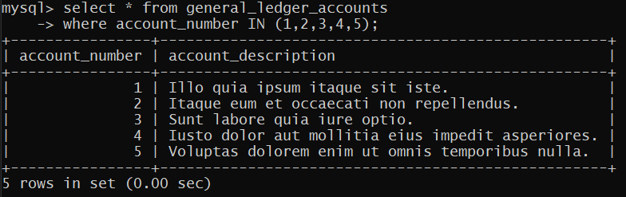

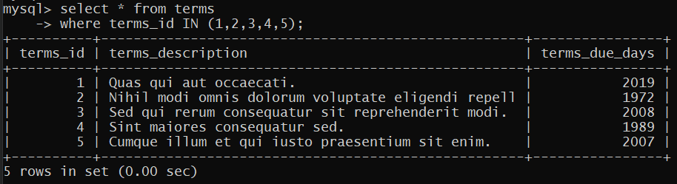

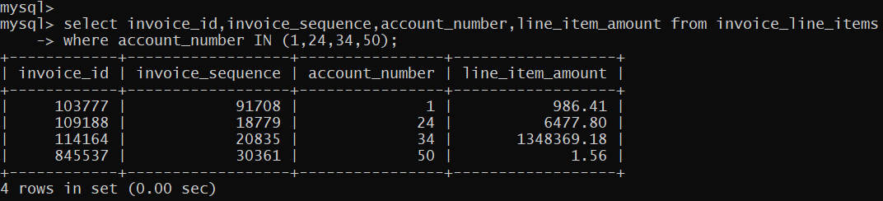

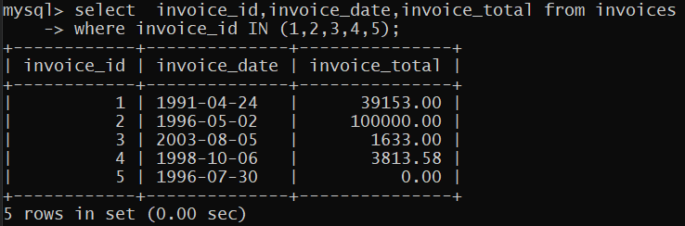

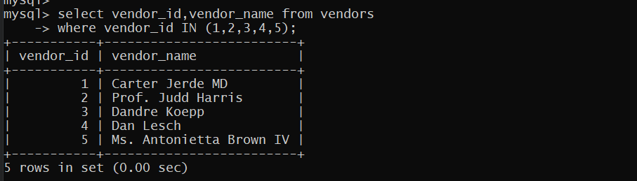

PTO

## PART:3

### *QUERY: TRIGGER 1*

/*1 trigger: BEFORE delete on terms table as it is foreign key constrained*/

DELIMITER //

CREATE TRIGGER deleteTermsNotAllowed

BEFORE DELETE ON terms FOR EACH ROW

BEGIN

signal sqlstate '49001' SET message_text = "DELETE on terms forbidden (foreign key restrained)!";

END //

DELIMITER ;

DELETE FROM terms;

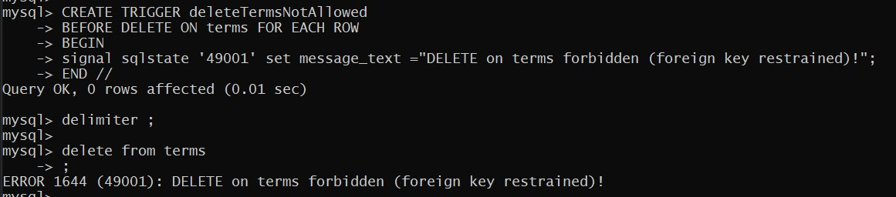

### *3.2 QUERY: TRIGGER 2*

/*2 trigger: BEFORE delete on general Ledger Accounts table as it is foreign key constrained*/

DELIMITER //

CREATE TRIGGER deleteAccountsNotAllowed

BEFORE DELETE ON general_ledger_accounts FOR EACH ROW

BEGIN

signal sqlstate '49002' SET message_text = "DELETE on general_ledger_accounts forbidden (foreign key restrained)!";

END //

DELIMITER ;

DELETE FROM general_ledger_accounts;

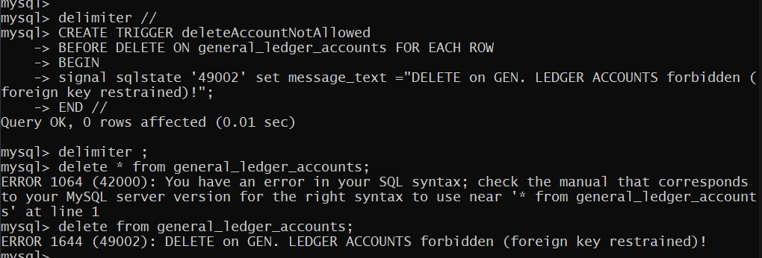

### *3.3 QUERY: TRIGGER 2*

/*3 trigger: BEFORE INSERT on invoices table discount 10% if invoice_total > 100000 */

DELIMITER //

CREATE TRIGGER updateInvoiceDiscount

BEFORE INSERT ON invoices FOR EACH ROW

BEGIN

IF new.invoice_total > 100000 THEN

SET new.invoice_total = (new.invoice_total)*0.9;

END IF;

END //

DELIMITER ;

INSERT INTO invoices(vendor_id,invoice_number,invoice_date,invoice_total,credit_total,terms_id,invoice_due_date,payment_date)

VALUES (50,'499700','2012-08-23',1000099,48379.32,1,'2012-11-23','2012-09-23');

SELECT (invoice_total) FROM invoices

WHERE vendor_id = 50 AND terms_id = 1;

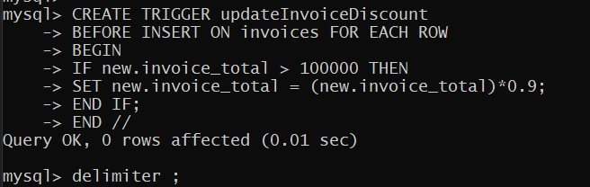

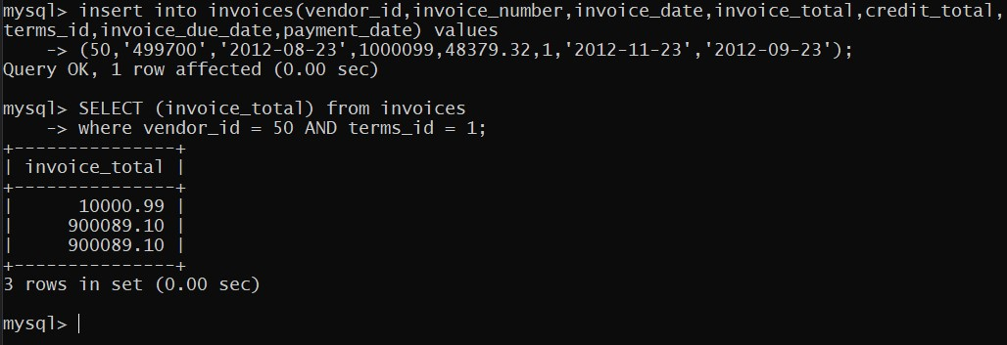

### *3.4 QUERY: PROCEDURE 1*

/*4 Procedure: To get names of all vendors*/

DELIMITER //

CREATE PROCEDURE getvendors(INOUT vendorslist VARCHAR (10000))

BEGIN

DECLARE isdone INT DEFAULT 0;

DECLARE vendorname varchar(50);

DECLARE vendorcursor CURSOR FOR

SELECT vendor_name from vendors;

DECLARE CONTINUE HANDLER FOR NOT FOUND SET isdone = 1;

OPEN vendorcursor;

vendorloop: LOOP

FETCH vendorcursor INTO vendorname;

IF isdone = 1 THEN

LEAVE vendorloop;

END IF;

SET vendorslist = CONCAT(vendorname, ", ", vendorslist);

END LOOP vendorloop;

CLOSE vendorcursor;

END //

DELIMITER ;

SET @vendorlist = "";

CALL getvendors(@vendorlist);

SELECT @vendorlist;

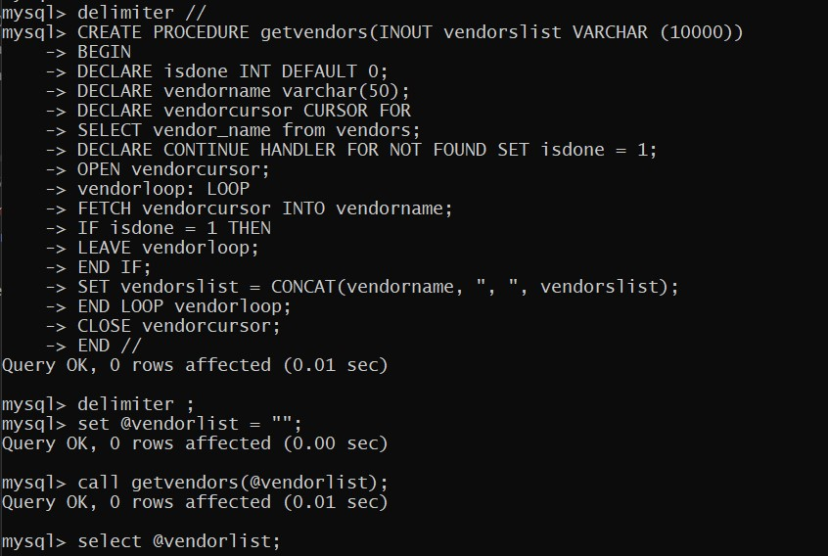

***OUTPUT:***

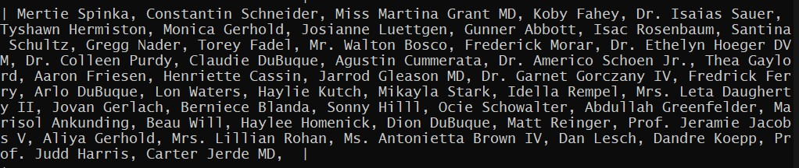

PTO

### *3.5 QUERY: PROCEDURE 2*

/*5: procedure to add late fees*/

-- there were no dates greater than current date so added a few

update invoices

SET payment_date = '2021-10-21'

WHERE invoice_id IN (1,3,5,7,9);

-- some invoice_total values were offlimit, thus

update invoices

SET invoice_total = 100000

WHERE invoice_total > 100000

-- glimpse of values about to be updated

select invoice_id,invoice_total,'NOT updated payment' from invoices

WHERE invoice_id IN (1,3,5,7,9);

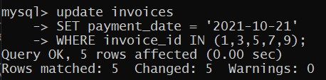

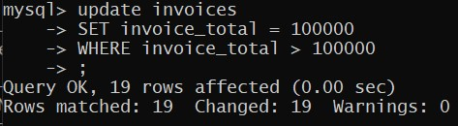

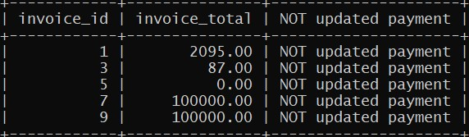

-- procedure

DELIMITER //

CREATE procedure addlatepayment()

BEGIN

DECLARE isdone INT DEFAULT 0;

DECLARE invid INT DEFAULT 0;

DECLARE invtotal INT DEFAULT 0;

DECLARE oldpayment INT DEFAULT 0;

DECLARE invpdate date DEFAULT 0;

DECLARE invcursor CURSOR FOR

SELECT invoice_id,payment_date,invoice_total FROM invoices;

DECLARE CONTINUE HANDLER FOR NOT FOUND SET isdone = 1;

OPEN invcursor;

invloop: LOOP

FETCH invcursor INTO invid,invpdate,invtotal;

SET oldpayment = invtotal;

IF isdone = 1 THEN

LEAVE invloop;

END IF;

IF invpdate > CURDATE() THEN

SET invtotal = invtotal * 1.05;

UPDATE invoices

SET invoice_total = invtotal

WHERE invoice_id = invid;

SELECT invoice_id as ID,oldpayment as PREVIOUS_TOTAL,invoice_total as UPDATED_TOTAL,'UPDATED' as STATUS from invoices

WHERE invoice_id = invid;

END IF;

END LOOP invloop;

SELECT 'Late dues added successfully';

CLOSE invcursor;

END //

DELIMITER ;

-- calling PROCEDURE

call addlatepayment();

--actually whole table is traversed but

--here only those tuples shown which were actually updated

PTO

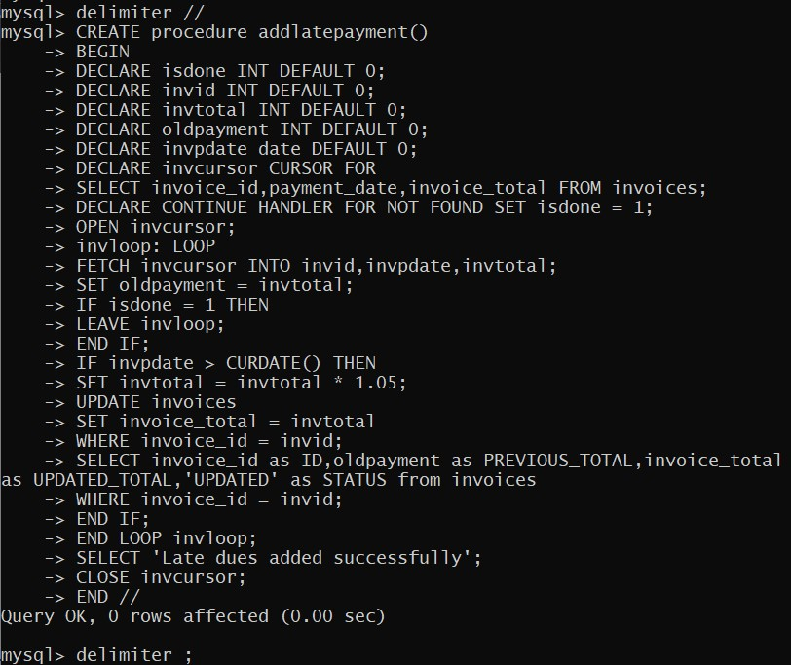

PTO

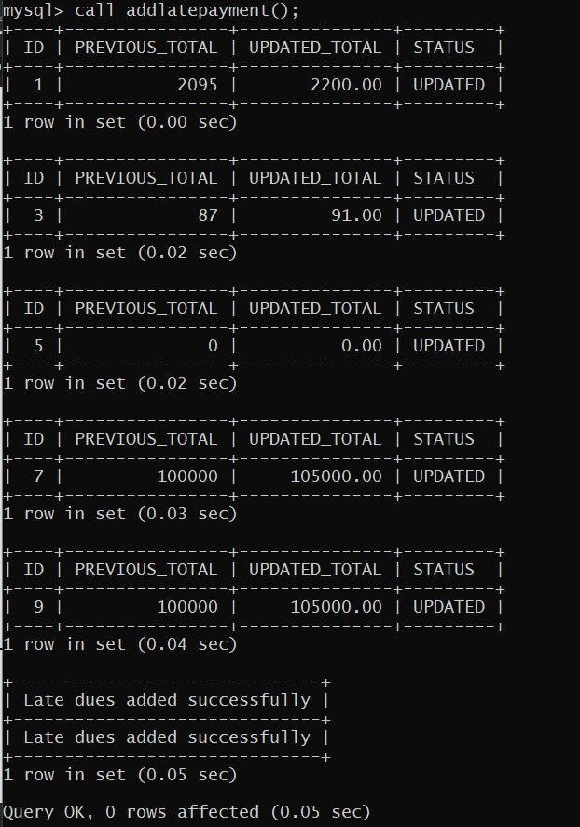

### *3.6 QUERY: PROCEDURE 3*

/*6: procedure to show due payments*/

-- procedure

DELIMITER //

CREATE procedure showduepayments()

BEGIN

DECLARE isdone INT DEFAULT 0;

DECLARE invid INT DEFAULT 0;

DECLARE invtotal INT DEFAULT 0;

DECLARE invpdate date DEFAULT 0;

DECLARE cursorinv CURSOR FOR

SELECT invoice_id,payment_date,invoice_total FROM invoices;

DECLARE CONTINUE HANDLER FOR NOT FOUND SET isdone = 1;

OPEN cursorinv;

invloop: LOOP

FETCH cursorinv INTO invid,invpdate,invtotal;

IF isdone = 1 THEN

LEAVE invloop;

END IF;

IF invpdate > CURDATE() THEN

SELECT invoice_id as ID,payment_date,invoice_total as DUE_INVOICE,'PENDING' as STATUS from invoices

WHERE invoice_id = invid;

END IF;

END LOOP invloop;

CLOSE cursorinv;

END //

DELIMITER ;

-- calling PROCEDURE

call showduepayments();

PTO

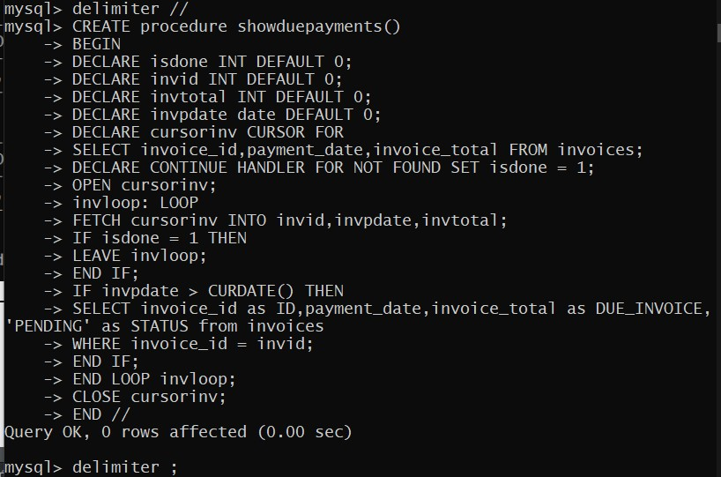

*PTO*

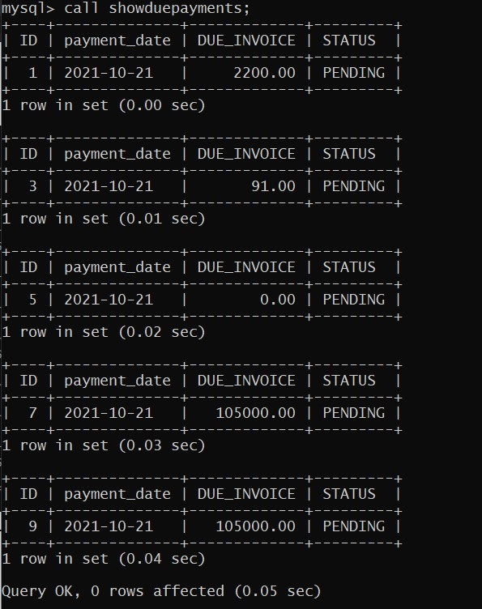

PTO

### *3.7 QUERY: SCHEDULED EVENT 1*

/*7: Timestamp trigger to run procedure addlatepayment() daily once*/

-- to run scheduled events event organiser should be ON

-- set it to 0 to turn it OFF

SET GLOBAL event_scheduler = 1;

-- sample event to see results if working

CREATE EVENT updatepayment

ON SCHEDULE EVERY 5 SECOND

DO

CALL dswproject.addlatepayment();

select invoice_id,invoice_total from invoices

where invoice_id IN (1,3,5,7,9);

-- repeat after 5 seconds

select invoice_id,invoice_total from invoices

where invoice_id IN (1,3,5,7,9);

--dropping sample event

drop event if exists updatepayment;

*7eventenable*

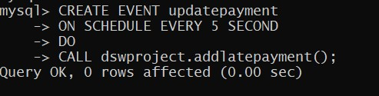

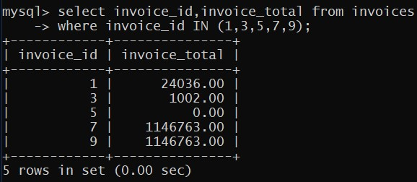

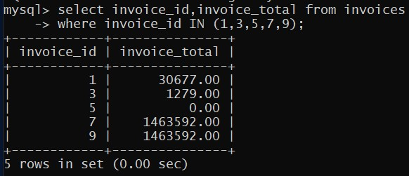

## 4. BIBLIOGRAPHY

[1] MySQL scheduled events

<https://www.mysqltutorial.org/mysql-triggers/working-mysql-scheduled-event/>

1. MySQL Reference Manual  
   <https://dev.mysql.com/doc/>
2. Murach’s MySQL 3rd Edition (book)
3. StackOverflow (for finding solutions to errors)

END